GPSx Assignment report

Lavanya Kudli

9th May 2023

CEE 538

**MODELLING APPROACH**

The purpose of modelling unit processes is to provide recommendations for an upgrade at Peoria wastewater treatment plant (WWTP). The upgrade involves replacement of the current aerobic reactor configuration to anaerobic-anoxic-oxic (A2O) process. Using the A2O setup nitrogen and phosphorus nutrient removal can be achieved. Overall, the Anaerobic reactors can be used for phosphorus removal while the anoxic and aerobic reactors can be used for denitrification and nitrification. Additionally, the aerobic reactors will also aid in BOD removal.

To assess the upgrade, a model was constructed in GPSx software. The CSTRs in series were modelled using the “PFR” reactor. 4 PFR reactors were created: ANA (Anaerobic), ANX-Swing (Anoxic-Swing), AER P2 (Aerobic Pass 2), AER P3 (Aerobic Pass 3). Each zone is 160.5 m3. For each reactor the sidewall depth is 4.72 meters. These reactors were modelled based on Asm2d model. The influent conditions to the anaerobic reactor was based on the data provided in the worksheet.

An internal recycle was added connecting the final aerobic zone to the flow entering the first anoxic zone (this internal recycle is to send nitrate back to the anoxic zones). The internal recycle flow was set as 14,500 m3/d, this was twice the forward flow.

The thickener was assumed to have a fixed “removal efficiency” of 90% and the underflow solids concentration was assumed to be 40,000 mg/L. The thickened sludge is transferred into a sludge handling truck for disposal.

The secondary clarifier was based on empirical data and TSS removal was evaluated for two scenarios: Case 1: Clarifier removal efficiency of 99.5% and Case 2: Clarifier removal efficiency of 99.9%. The maximum allowable TSS effluent limit was 20mg/L for the purpose of providing recommendations.

The clarifier RAS was split into two streams using a splitter. The Ras is returned and the Was is then sent to the thickener. The initial flow rate of WAS is set to 30 m3/day. Later, the Was flow rate was added as a controller to evaluate system performance. This flowrate was varied from 15 to 500 m3/day. All the simulations were run at steady-state.

The SRT were defined using the F(x) button, four different SRTs were defined for the system. SRT (ana), SRT (anx), SRT (aer) and, SRT control. The SRT control was defined as the total SRT of the system. The influence of different variables listed in Table 1 on SRT control across different scenarios was evaluated. The scenarios considered in the study were summer and winter time conditions. Additionally, two reactor confiugrations A2O and AO were evaluated for winter time conditions.

Lastly, the DO set points were assumed to be zero for the anoxic reactor in the A2O scenario. The DO set points were assumed to be 2 for the anoxic reactor in the A2O scenario. Rest of the DO set points were not modified and left as default.

Figure 1: Process flow diagram, controller, and simulation space

**SCENARIOS EVALUATED**

Across three scenarios, each of the variables were evaluated against SRT control. This was done for two cases: Case 1, and Case 2. Not all variables were evaluated for both cases and (highlighted in Table 1). The variables highlighted in bold are the ones that were used to make recommendations about the cost of aeration. Aeration rate (m3/d) for all the reactors were plotted against the SRT control. The rate of aeration can be a direct indication of the cost of aeration and was used as a variable. The volumetric waste flow rate can also be directly correlated with the cost of waste disposal and hence was also evaluated against SRT control. The range of SRT total for all the cases was from 0 to 30. For a few cases (underlined variables), the SRT total range was from 0-40.

|  |  |  |  |
| --- | --- | --- | --- |
| Scenarios | Variables | Case 1: Clarifier performance (99.5%) | Case 3: Clarifier performance (99.9%) |
| ***Summer scenario (A2O)***  ***Winter scenario (A2O)***  ***Winter scenario (AO)*** | WAS  (m3/d) | Yes | Yes |
| srtcontrol  (d) | Yes | Yes |
| Total BOD5  (mgO2/L) | Yes | Yes |
| Ammonia nitrogen  (mgN/L) | Yes | Yes |
| Nitrate and nitrite  (mgN/L) | Yes | Yes |
| Total nitrogen  (mgN/L) | Yes | Yes |
| Total Phosphorus  (mgP/L) | Yes | Yes |
| Ortho-phosphate  (mgP/L) | Yes | Yes |
| **Aeration ANX Swing (1)**  **(m3/d)** | Yes | No |
| **Aeration ANX Swing (2)**  **(m3/d)** | Yes | No |
| **Aeration AER (1)**  **(m3/d)** | Yes | No |
| **Aeration AER (2)**  **(m3/d)** | Yes | No |
| **Aeration AER (3)**  **(m3/d)** | Yes | No |
| **Aeration AER (4)**  **(m3/d)** | Yes | No |
| **Waste flow**  **(m3/d)** | Yes | No |

Table 1: Table for all the scenarios covered in the study

**TRENDS AND OBSERVATIONS**

1. **Plot comparing TSS in the secondary effluent for two clarifier removal efficiency scenarios for summer time conditions.**

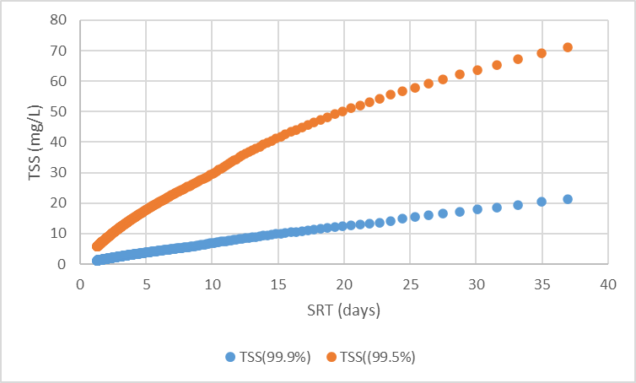

**Key takeaways:**

* When the clarifier removal efficiency was increased from 99.5% to 99.9%, the secondary effluent TSS concentration decreased significantly.
* At 99.9% clarifier efficiency, the WWTP can stay within the max effluent TSS limit of 20 mg/L.

**Recommendation:**

* The WWTP should take into consideration additional costs associated with improving clarifier performance. Additionally, the WWTP can also investigate different clarifier configurations like series and parallel train setups and evaluate their removal efficiency.

1. **Plot comparing total cBOD across all the scenarios (99.5% clarifier removal efficiency and 99.9% clarifier removal efficiency)**

**Case 1**

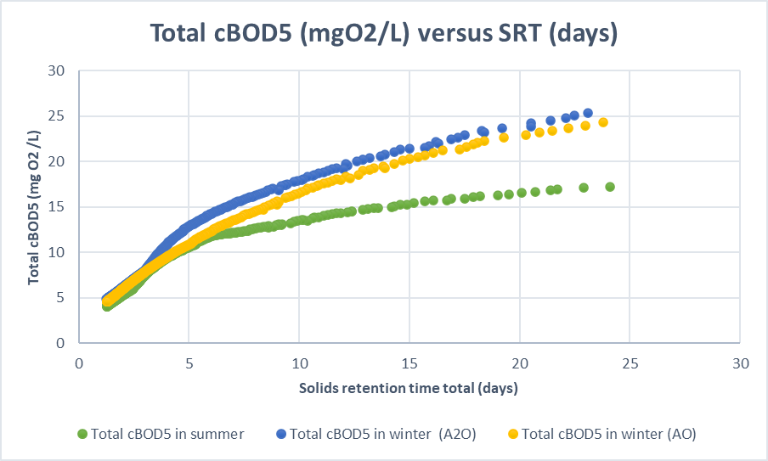

**Case 2**

**Key takeaways:**

* The filtered carbonaceous BOD5 is increasing with increase in SRT for both the scenarios.
* The effluent cBOD is much lower for the second case with a better clarifier performance.
* The poor performance of the first scenario can be attributed to inefficient treatment and decay of heterotrophic microorganisms at longer SRTs.
* The summer cBOD5 is lower than winter-time cBOD5 possibly due to better kinetics at higher temperatures. Both winter-time cBOD5 removals are the same

**Recommendations:**

* Ensure sufficiency supply of oxygen in the aerobic reactors to facilitate BOD removal.
* Inspect the type of BODs in the wastewater through testing to see if the microorganisms can remove the different types of BOD5 present in the wastewater.
* Since the cBOD almost plateaus beyond SRT of 15, an SRT total in the range of 12-15 and a better performing clarifier (case 2) can be used.

1. **Plot comparing nitrite and nitrate concentration vs SRT across all the scenarios for (99.5% clarifier removal efficiency and 99.9% clarifier removal efficiency)**

**Case 1**

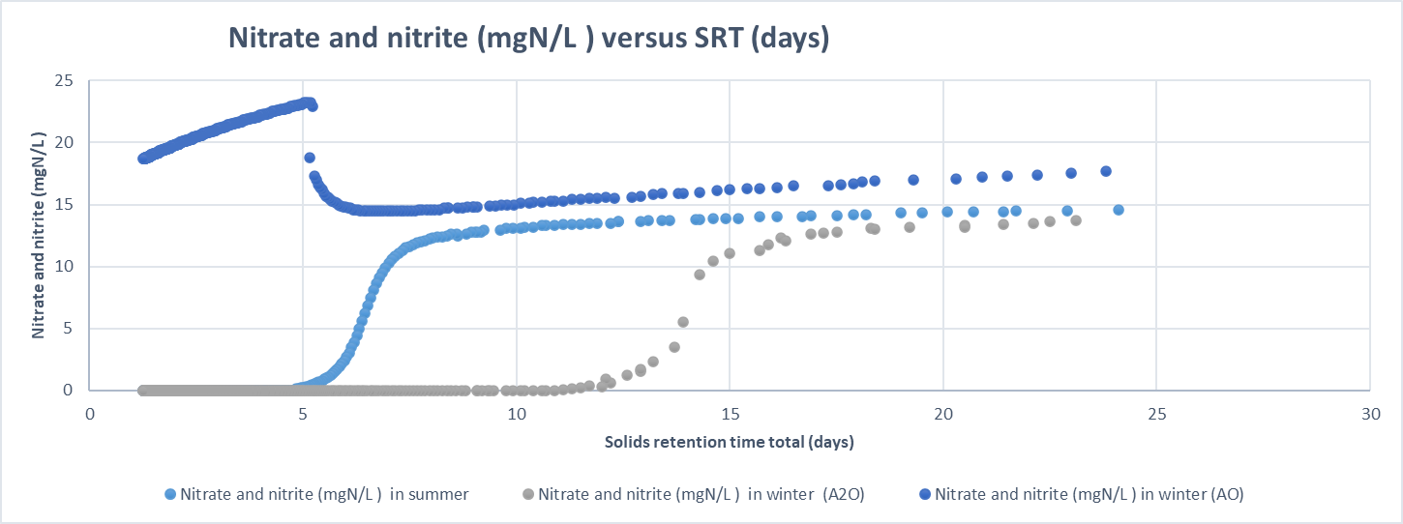

**Case 2**

1. **Plot comparing ammonia nitrogen (mgN/L) in the secondary effluent versus SRT across all the scenarios for (99.5% clarifier removal efficiency and 99.9% clarifier removal efficiency)**

**Case 1**

**Case 2**

**Key takeaways from nitrate and nitrite concentration plots and ammonia nitrogen plots**

**Key takeaways:**

* The ammonia concentration decreases as the SRT increases due to an increase in nitrification with an increase in SRT for summer (A2O) and winter (AO). In case 1, the SRT at which nitrification starts taking place for summer (A2O) and winter (AO) scenarios is close to 6. In case 2, the SRT at which nitrification starts taking place for summer (A2O) and winter (AO) scenarios is close to 3-4.
* However, in winter A2O due to one lesser aerobic reactor and slower kinetics the nitrification starts taking place at a slightly higher SRT. Based on all the four plots, For case 1, winter A2O nitrification SRT is around 12 and case 2 it is close to 10.
* These observations are in tune with the nitrate and nitrite concentration plots. The nitrate and nitrite concentrations appear in the effluent after nitrification SRT’s for both case 1 and case 2 across all the scenarios.

**Recommendations:**

* Case 1: To achieve ammonia removal and nitrification, an SRT total of 6 should be used for summer (A2O) and winter (AO) and an SRT total around 12 should be used for wintet (A2O scenario).
* Case 2: To achieve ammonia removal and nitrification, an SRT total of 5 should be used for summer (A2O) and winter (AO) and an SRT total around 10 should be used for wintet (A2O scenario).
* Overall, the clarifier performance does not really matter for ammonia removal. Since, the SRT totals required to achieve low ammonia concentration for both cases are quite similar.
* The WWTP should check if it also must meet nitrite and nitrate concentration limits. Based on how stringent it is, other nutrient removal strategies such as algae-based treatment can be adopted.

1. **Plots comparing total nitrogen (mgN/L) in the secondary effluent versus SRT effluent versus SRT across all the scenarios for (99.5% clarifier removal efficiency and 99.9% clarifier removal efficiency)**

**Case 1**

**Case 2**

**Key takeaways:**

* Overall, at SRT total higher than 15, case 2 achieves lower total nitrogen concentration (~ 15 mgN/L) in the effluent as compared to case 1 (~17 mgN/L) for summer (A2O) and winter (AO) scenarios.

**Recommendation:**

* To achieve a nitrogen conc of ~13 mgN/L, the WWTP should operate at SRTs between 6-11 for a clarifier with a better performance (99.9%).
* On the other hand, if a nitrogen concentration effluent limit is more flexible, the WWTP should operate at a higher SRT(10- 17) at a lower clarifier performance (99.5%) to achieve a total nitrogen effluent conc of ~15 mgN/L
* The plots for winter A2O need to be assessed to provide a reliable recommendation.

1. **Plots comparing total phosphorus (mgP/L) in the secondary effluent versus SRT across all the scenarios for (99.5% clarifier removal efficiency and 99.9% clarifier removal efficiency)**

**Case 1**

**Case 2**

1. **Plots comparing total orthophosphate concentrations (mgP/L) in the secondary effluent versus SRT across all the scenarios for (99.5% clarifier removal efficiency and 99.9% clarifier removal efficiency)**

**Case 1**

**Case 2**

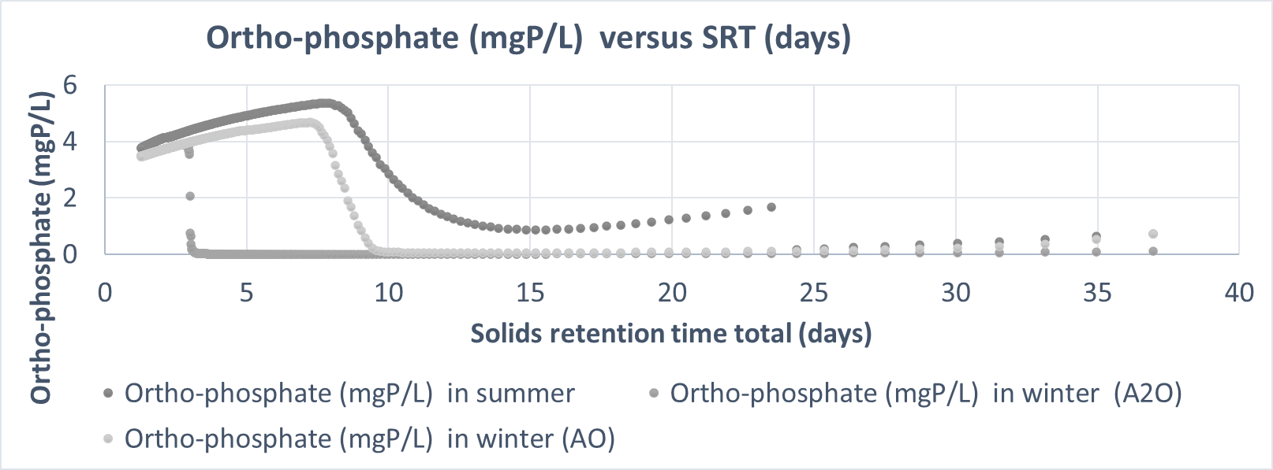

**Key takeaways for phosphorus removal based on plots for total phosphorus and ortho-phosphate concentration in the secondary effluent.**

* **Total P**
* In case 1, after SRT of 10 days, the total phosphorus concentration in the effluent in all the scenarios summer(A2O), winter (AO) and winter (A2O) is the same and increases with SRT. There is an increase in the phosphorus concentrations in the winter scenarios beyond an SRT of 3 days.
* In case 2, close to zero total phosphorus concentrations can be seen for winter (A2O) at SRT of ~3.
* **Ortho-phosphate**
* In case 1, after SRT of 10 days, the total orthophosphate concentration across all the scenarios increases and approaches zero. However, in case 2, the summer performance is not as good as case 1. For case 2, the summer ortho-phosphate concentration decreases after an SRT of 8 whereas for case 1, the summer ortho-phosphate concentration decreases after SRT of 3 days.

**Recommendation:**

* In the case with clarifier with a low removal efficiency (case 1), the total P concentrations increases with the SRT.
* To meet lower effluent P limits, the WWTP should use a clarifier with a higher performance. The operating SRT should be around 10 for summer (AO) and winter (A2O). For achieving low ortho-phosphate concentrations, an SRT of around 9 days need to be used for summer and winter (A2O) and around 3 for winter (AO).
* Overall, having an SRT of 10 and a clarifier performance of 99.9% will ensure low levels of P and ortho-phosphate concentration across all the three scenarios.

1. **Plots to compare aeration requirements across all scenarios for all the reactors**

Figure 2

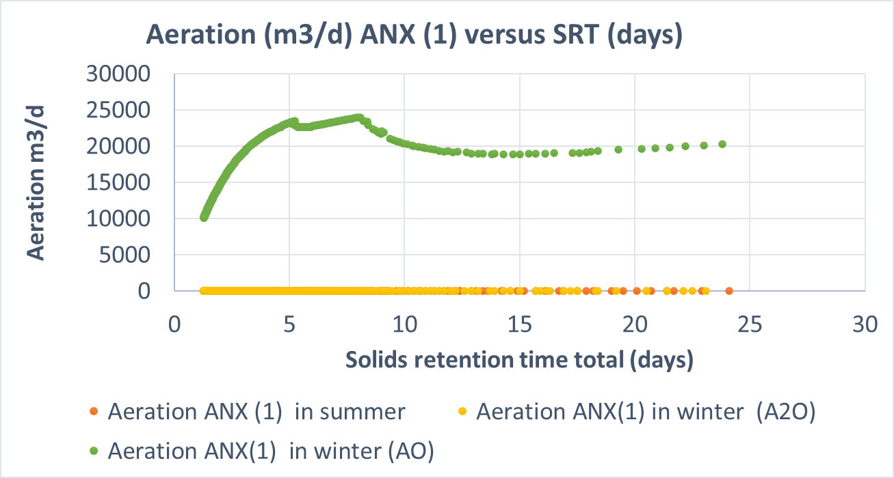

Figure 3

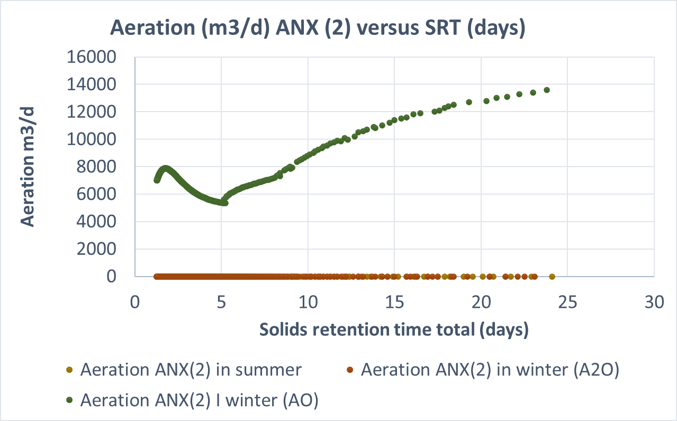

Figure 4

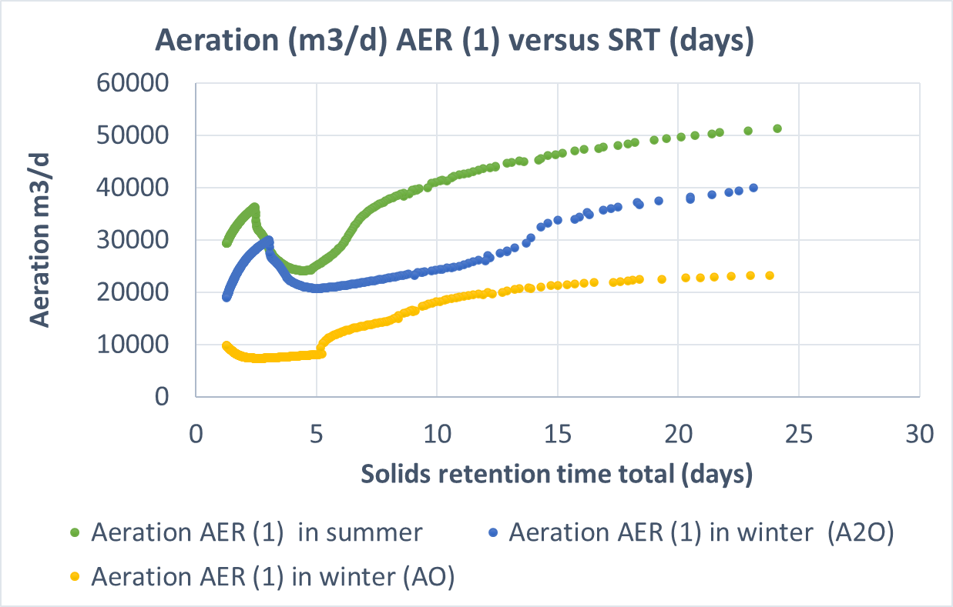

Figure 5

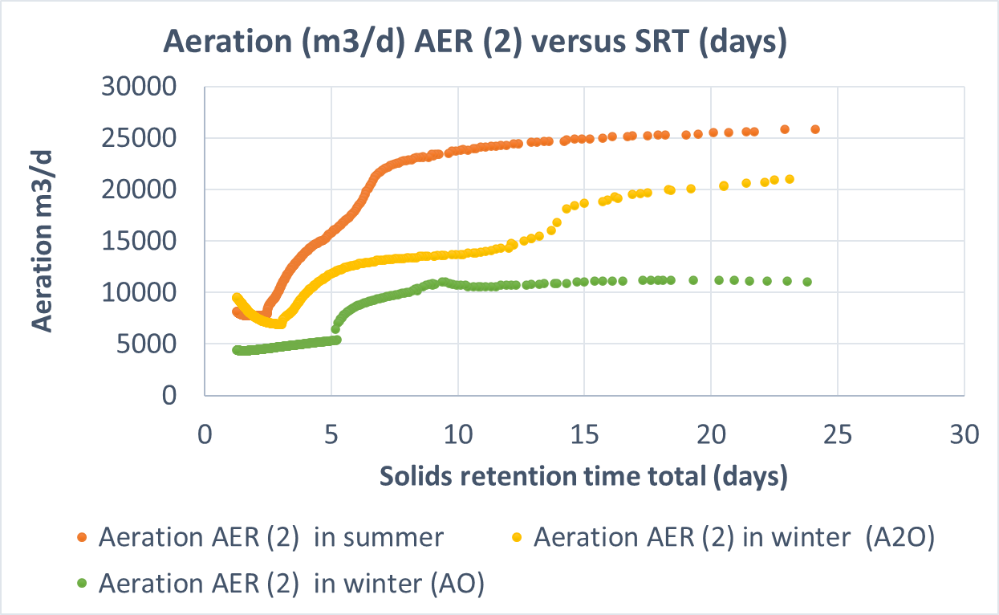

Figure 6

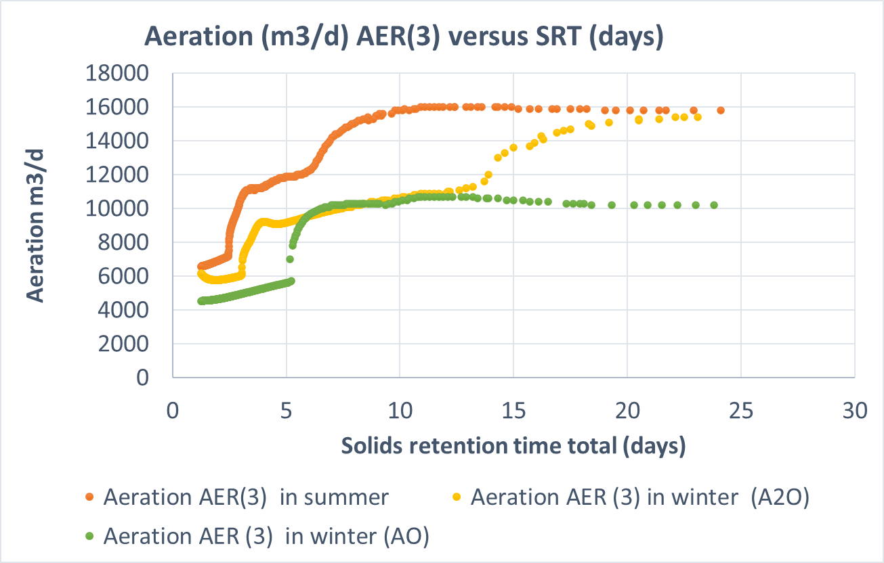

Figure 7

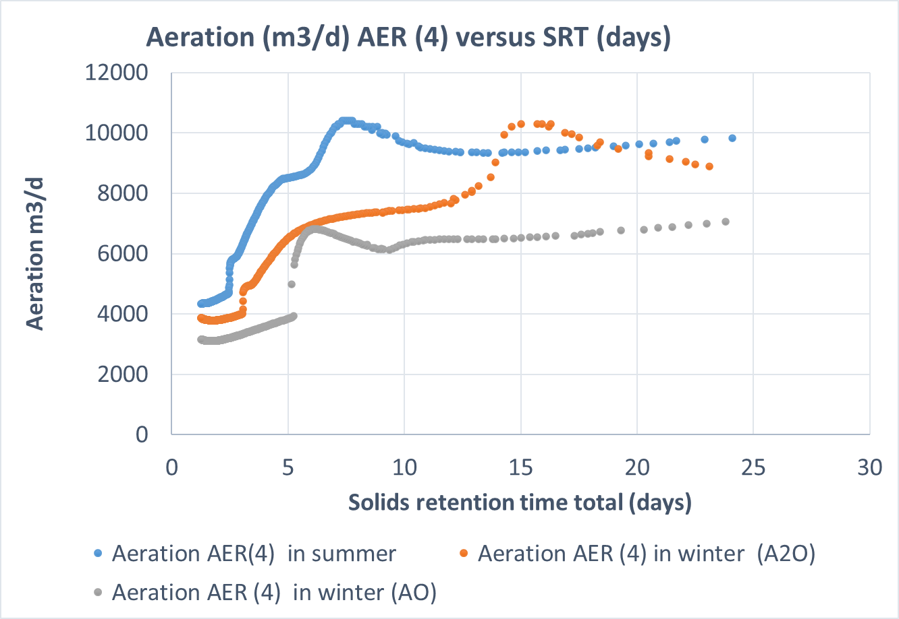

**Key takeaways:**

* In the above Figures (4-7), the aeration demand in summer (A2O) is higher than in winters. This can possibly be because of higher growth rate of biomass leading to higher consumption of oxygen.
* For Figures 2 and 3, the only time aeration is required is when the anoxic reactors are converted into aerobic reactors (AO setup). Therefore, the aeration demand is only during the winter times where AO reactor configurations are used.
* The first aerobic reactor (AER 1 and 2) given by Figure 4 and 5 has a much higher aeration demand than the second aerobic reactor.
* This is because, the influent of the first aerobic reactor is coming from an anoxic reactor which does not have any oxygen. This leads to a high aeration requirement. Second aerobic reactor has some influent oxygen coming from the previous aerobic reactor. Therefore, requirements of the second aerobic reactors are lower (AER 3 and AER 4), Figure 6 and 7.

1. **Plot for volumetric waste disposal across all the scenarios**

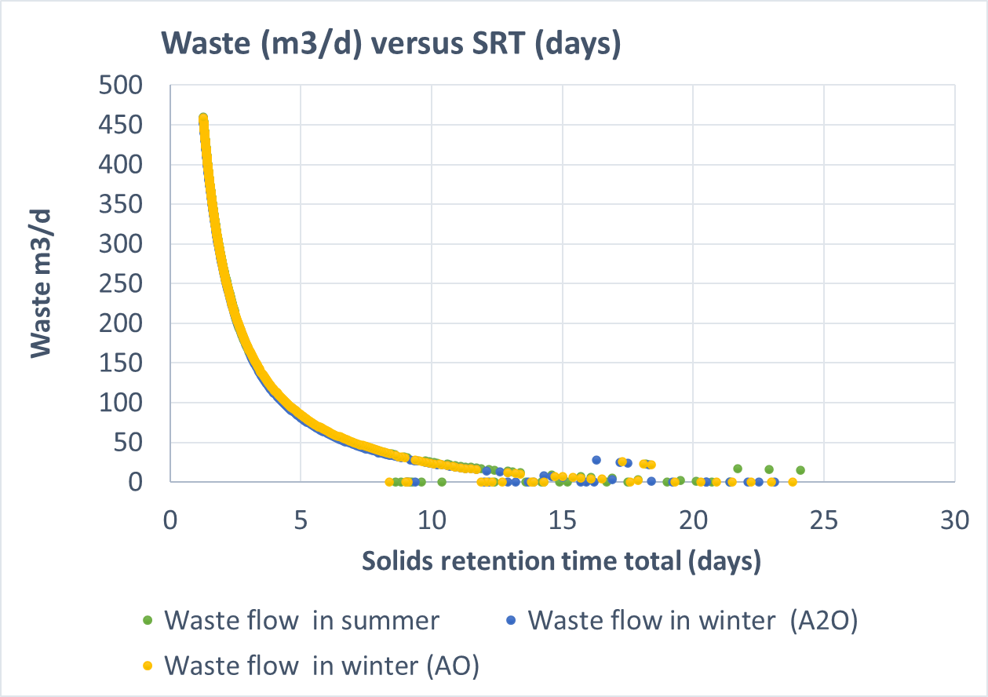

The plot for volumetric waste disposal is provided in the above figure. It should be reassessed before providing any recommendations. Ideally, it should change based on the temperature as, more sludge is typically generated in the summer than winters.

**FINAL RECOMMENDATIONS**

To achieve low concentrations of BOD, Nitrogen and Phosphorus the following SRT total can be chosen based on weather conditions and subject to different clarifier performances.

1. **Total SRT in summer across variables and cases**

|  |  |  |
| --- | --- | --- |
|  | Case 1(99.5% clarifier removal eff.) | Case 2 (99.9% clarifier removal eff.) |
| bCOD (should be reassessed) | 10 | 10 |
| Ammonia and total N conc. in the effluent | 4 | 3 |
| Total Phosphorus | 3 | 7 |
| Orthophosphaste | 2 | 7 |

1. **Total SRT in winter**

**Winter (A2O)**

|  |  |  |
| --- | --- | --- |
|  | Case 1(99.5% clarifier removal eff.) | Case 2 (99.9% clarifier removal eff.) |
| bCOD (should be reassessed) | - | - |
| Ammonia and total N conc. in the effluent | 12 | 11 |
| Total Phosphorus | 4 | 3 |
| Orthophosphaste | 3 | 3 |

**Winter (AO)**

|  |  |  |
| --- | --- | --- |
|  | Case 1(99.5% clarifier removal eff.) | Case 2 (99.9% clarifier removal eff.) |
| bCOD (should be reassessed) | - | - |
| Ammonia and total N conc. in the effluent | 7 | 5 |
| Total Phosphorus | 8 | 7 |
| Orthophosphaste | 8 | 7 |

1. **Aeration or no aeration of swing zones in winter**

Aeration of swing zones leads to a lower SRT requirement for N removal and a higher SRT requirement for P removal. However, the SRT total required to achieve both is 8 in case 1 of AO and 7 in case 2 of AO.

**The plant can opt for Aeration of the swing zone**. But this would come at a cost as the aeration rate requirements for the anoxic swing reactors are 8000 m3/d and 25000 m3/d at an SRT of 8.

A more reliable analysis of waste production can also provide more insights.

Additionally, having a clarifier with a better performance does ensure a lower TSS effluent concentration in summertime conditions. This should be revaluated for both the wintertime conditions.